Quantitative, Multispecies Monitoring at a Continental Scale

2025-04-03

# 

|  |  |
| --- | --- |
| 1 | School of Marine and Environmental Affairs, University of Washington, Seattle, Washington, USA |
| 2 | Conservation Biology Division, Northwest Fisheries Science Center, NOAA Fisheries, |
|  | Montlake Blvd E. Seattle, Washington, USA |
| 3 | Museo Nacional de Ciencias Naturales CSIC, Madrid, Spain |
| * | **Gledis Guri**, lead and corresponding author **gguri@uw.edu** |

# Author Contributions

AOS, KMN, RPK, MS, and KP designed the research;  
MRS, AR-L and AW did the laboratory work;  
PB, RPK, and GG did the bioinformatics;  
GG, OL, RPK, and AOS analyzed the data;  
GG, OL, RPK, and AOS interpreted the results;  
All authors provided edits to the manuscript

# Author Declaration

The authors declare no competing interest.

# Keywords

eDNA $|$ natural resources $|$ bio-monitoring $|$ quantification $|$ fish

# Acknowledgment

We thank Linda Park for her foresight and perseverance, Katherine Maslenikov (University of Washington Burke Museum Ichthyology Collection) for providing tissue samples for the mock community analysis, and Olivia Scott for validation and Sanger sequencing of the mock communities. This material is based upon research supported by the Office of Naval Research under Award Number (N00014-22-1-2719) and support from the National Marine Fisheries Service’s Genomic Strategic Initiative. The authors gratefully acknowledge the survey expertise and support of NOAA NWFSC’s Pacific hake survey team and the personnel of the NOAA Ship Bell M. Shimada for supporting the collection of eDNA samples on the west coast hake survey 2019 - 2023. Any use of trade, firm, or product names is for descriptive purposes only and does not imply endorsement by the U.S. Government.

# Abstract

Molecular data from environmental samples can reflect the abundance of species’ DNA, an index immediately relevant to natural-resources management at a broad geographic scale. These data commonly derive from assays designed and targeted for specific species (e.g., using qPCR or ddPCR), or metabarcoding assays from more general PCR primers that amplify many species simultaneously. Multispecies analyses make efficient use of field samples and laboratory time, and speak to inherently multispecies questions of management and ecological interest. However, unlike single-species techniques, metabarcoding by itself can reflect only the proportions of target-species DNA present, not their absolute quantities. Here, we combine qPCR and metabarcoding data derived from the same samples to map quantities of many fish species along the US West Coast in three dimensions, demonstrating a technique of practical importance for both management and ecology. We derive spatially explicit estimates of eDNA abundance for 12 common species of ecological and management importance and point the way to quantitative surveys of wild species using molecules alone. We find that species distribution maps derived from eDNA effectively capture species niches and spatial distributions. Notably, our analyses identified biodiversity hotspots that align with previously documented regions of ecological significance, such as the Columbia River plume and the Heceta Bank.

# Introduction

Environmental DNA (eDNA, residual genetic material sampled from water, soil, or air) is an increasingly common tool for non-invasively sampling marine and aquatic ecological communities, valuable for estimating species occurrence (Veilleux, Misutka, and Glover 2021), biodiversity (i.e., richness, (Muenzel et al. 2024)), and genetic structure (Andres, Lodge, and Andrés 2023). However, eDNA has not been widely used for quantitative abundance estimation, upon which many practical management and conservation applications rely (but see (Andrew Olaf Shelton et al. 2022; Guri, Shelton, et al. 2024; Stoeckle, Ausubel, and Coogan 2022)). The use of eDNA for quantification is supported both conceptually – where there is more of a species, more cells are shed in the environment, and thus there is more DNA – and empirically (e.g. there are strong linkages between single-species eDNA measures of in aquaria (Jo et al. 2019; Ledger et al. 2024), rivers and streams (Pont 2024), estuaries and nearshore habitats (DiBattista et al. 2022; Baetscher, Nuetzel, and Garza 2023), and coastal oceans (Maes et al. 2024; Andrew O. Shelton et al. 2019)). However, uses of quantitative eDNA observations in management applications have significantly lagged behind their use in occurrence and biodiversity applications.

Quantitative estimates of DNA are more common with species-specific assays (e.g. qPCR and ddPCR) because these approaches directly measure DNA concentration. In contrast, multispecies analysis (metabarcoding) reflects information on many species of interest simultaneously, but at the costs of producing compositional estimates of proportional abundance (Gloor et al. 2017; McLaren, Willis, and Callahan 2019) that may require statistical correction for species-specific biases due to PCR amplification (Andrew O. Shelton et al. 2023). Consequently, metabarcoding data alone cannot yield information about the abundance of DNA from environmental samples (e.g. (Guri, Shelton, et al. 2024)).

Surveys of marine environments play a fundamental role in supporting fisheries and conservation of protected species but are often difficult and expensive endeavors. While trawling, acoustics, or other traditional sampling methods have long been used to directly measure species abundance and biomass, they can be impractical for species inhabiting inaccessible habitats, occurring at low densities, or for fragile species easily injured during capture. By contrast, eDNA sampling captures information on a broader range of taxa, including those that are difficult or impossible to study with traditional gear. As such, eDNA can meaningfully complement traditional stock assessment methods for commercially important species while at the same time revealing the abundance and distribution of elusive or understudied species.

Here, we develop quantitative estimates of eDNA abundance for a diverse group of fish species spanning different depth niches across 10 degrees of latitude along the US West Coast entirely from eDNA. We integrate single- and multi-species (using MiFish-U universal primers (Miya et al. 2015)) techniques to create three-dimensional distribution maps, leveraging models established in previous studies (Andrew Olaf Shelton et al. 2022; Guri, Shelton, et al. 2024; Andrew O. Shelton et al. 2023; Allan et al. 2023). By calibrating metabarcoding data – correcting raw species observations to their initial proportions using a mock community (Andrew O. Shelton et al. 2023) – and using the absolute eDNA quantity of a reference species (here Pacific Hake (*Merluccius productus*)), we expand initial estimated proportions into absolute estimates of the abundance of each species’ eDNA (Guri, Shelton, et al. 2024). We subsequently smooth the estimated eDNA quantities to generate species distribution maps (Liu et al. 2023). We present quantitative results for 12 fish species using eDNA, comparing them with literature-based species distributions to illustrate the approach, but note that it immediately generalizes to any ecological community of interest.

The eDNA-derived estimates we provide here speak directly to the requirements of natural-resources management at large scales. For example, indices of abundance have a central role in determining stock status for fisheries applications (i.e., stock assessments in the U.S. under the Magnuson-Stevens Act) as well as informing conservation status (e.g., under the U.S. Endangered Species Act). Thus eDNA-derived abundance indices can fill a variety of existing requirements for management. While these indices are still in their infancy and will require additional technical developments to ensure their proper usage, they are conceptually and practically little different from abundance estimates derived from more traditional ocean survey methods (i.e., net-based or acoustic surveys). Indeed, eDNA methods may provide some notable improvements because single- and multi-species eDNA approaches avoid tradeoffs involved with physically capturing many species simultaneously using a single net. Molecular surveys capture many species with the same “gear" using methods that are easily replicated in space and time. As U.S. agencies begin to implement the new National Aquatic eDNA Strategy (Kelly et al. 2024) – the first goal of which is to fold eDNA data into federal decisionmaking – this and other large-scale examples point the way to maximizing the benefit of this information-rich datastream for natural-resources management at a continental scale.

# Methods

## Sample Collection, Processing, and Quantitative PCR (qPCR)

We used samples collected in 10L Niskin bottles deployed on a CTD rosette at six depths (0, 50, 150, 300, 500 m) from stations along the West Coast of the US aboard the ship *Bell M. Shimada* during Summer 2019 on the Joint U.S.–Canada Integrated Ecosystem and Pacific Hake Acoustic-Trawl Survey (Blois 2020). 2.5L water samples were collected from each Niskin and filtered immediately on 47 mm diameter mixed cellulose-ester sterile filters with a 1 $μ$ m pore size, subsequently extracted using a phase-lock phenol-chloroform protocol, and analyzed in triplicate using a qPCR assay, multiplexed for Pacific hake, sea lamprey, and eulachon, as described in (Ramón-Laca, Wells, and Park 2021) and (Andrew Olaf Shelton et al. 2022). A subset of the samples (n = 554) collected in (Andrew Olaf Shelton et al. 2022), was used for metabarcoding analysis this study in addition to qPCR samples already published for hake quantification (Andrew Olaf Shelton et al. 2022) (n= 1,794).

## Metabarcoding: Environmental Samples and Mock Community

In total, 554 environmental samples were randomized and divided into 7 sequencing libraries for an Illumina MiSeq (v3 600 cycle kit). Total PCR reactions including PCR blanks (n = 7) and positive controls (n = 7), were amplified using MiFish-U universal primers (Miya et al. 2015) (see [SI Appendix Extended Methods](SI_Appendix.pdf) for details on metabarcoding methods). Importantly, we only analyzed one water sample collected from each sampling station using metabarcoding.

Sequences were de-multiplexed and the adapters removed by Illumina processing software tools. Primers were removed with Cutadapt v4.9 (Martin 2011). We then used DADA2 (default parameters, (Callahan et al. 2016)) to denoise sequences, remove chimeras, and generate amplicon sequence variants (ASVs). The sequences were then BLASTed against the NCBI nucleotide (nt) database (access: August 2024) using BLASTn algorithm with a cut off at 97% identity, assigning the least common ancestor of the top hit, resulting in species, genus, family, or higher rank classifications. Samples with fewer total number of reads than 1000 were filtered as an indicator of poor reliability. Of the initial environmental samples, 535 passed the quality filtering and 371 were selected for downstream analysis (see [SI Appendix, Fig. S3](SI_Appendix.pdf)) due to presence detection of Pacific hake in both qPCR and metabarcoding data streams (see [SI Appendix Extended Methods](SI_Appendix.pdf)). Details on bioinformatic pipeline are available in [SI Appendix Extended Methods](SI_Appendix.pdf).

To calibrate metabarcoding observations and account for amplification bias (Andrew O. Shelton et al. 2023; Gold et al. 2023), we generated multiple mock communities comprising a total of 39 fish species. Vouchered DNA extracts or tissues were obtained from either the University of Washington Fish Collection at the Burke Museum or the NOAA Northwest Fisheries Science Center collections. After quantifying the concentration of mitochondrial DNA template in each DNA extract, we constructed a total of eight mock communities of varying species compositions (see [SI Appendix, Table S1](SI_Appendix.pdf)). We selected 12 species (additional to Pacific hake) of commercial and ecological importance that co-occurred in the environmental samples and in the mock community for downstream analysis: Pacific herring (*Clupea pallasii*), northern anchovy (*Engraulis mordax*), northern smoothtongue (*Leuroglossus stilbius*), Dover sole (*Microstomus pacificus*), Pacific sardine (*Sardinops sagax*), Pacific chub mackerel (*Scomber japonicus*), widow rockfish (*Sebastes entomelas*), northern lampfish (*Stenobrachius leucopsarus*), California barracudina (*Tactostoma macropus*), plainfin midshipman (*Tarletonbeania crenularis*), eulachon (*Thaleichthys pacificus*), Pacific jack mackerel (*Trachurus symmetricus*). After amplification and sequencing using the protocols outlined above, we used the mock communities (which were run in the same PCR conditions as the environmental samples) to estimate species-specific amplification efficiencies and correct for amplification bias following (Andrew O. Shelton et al. 2023).

## Statistical analysis

To generate estimates of DNA concentration, we constructed a joint statistical model for qPCR and Mifish metabarcoding observations from the same samples. This model is based on the QM R package (www.github.com/gledguri/QM), with some modifications and advancements. The full statistical details are described in [SI Appendix Extended Methods](SI_Appendix.pdf), with an overview of the approach (Fig. 1). We used qPCR observations of hake DNA concentration for all water samples available (1,794 unique water samples were assayed and using a total of 5,394 qPCR reactions). This model takes observations of the PCR cycle at which amplification was detected in each field sample and estimates a hake DNA concentration for each water bottle collected at each sampling station-depth combination (Fig. 1). This statistical model accounts for sample-specific effects (e.g., dilution of the sample before PCR amplification), the effect of replicate water samples (a random effect), to provide estimates of hake DNA concentration in from each water sample collected at each location and depth (Fig. 1). This qPCR component of the joint model provides a quantification of DNA concentration for one species (Pacific hake) that can be connected to the multispecies proportions provided by DNA metabarcoding (Fig. 1).



Schematic for the statistical models to produce species distributions. Three sets of observations (orange) were used simultaneously to provide estimates of eDNA concentration for twelve fish species (blue) from which we derive smoothed predictions of DNA concentration (green). Mock communities for metabarcoding (yellow) were estimated externally and provided estimated $α_{s}$ that were used in the joint model. Notation for parameters, subscripts, and observations are indicated in gray.

Unlike single-species observation methods, metabarcoding data is compositional data. This means that each sample only provides information about relative species abundances rather than absolute DNA concentrations. Furthermore, metabarcoding does not yield a consistent, species-specific detection probability (i.e., sensitivity). Instead, the likelihood of detecting a particular species depends heavily on its competition with other sequences during PCR amplification (Andrew O. Shelton et al. 2023), as well as on the total sequencing depth for that sample (Kelly, Shelton, and Gallego 2019). Greater sequencing depth generally increases the probability of identifying rarer species, conditional on their DNA being collected and it being amplifiable with the chosen PCR primers.

We follow (Andrew O. Shelton et al. 2023) and construct a compositional model for the metabarcoding data from 371 of the water samples (after quality filtering) analyzed for Pacific hake qPCR. We use the metabarcoding observations of the 8 mock communities to calibrate the relative amplification efficiency of the 12 focal species (plus hake, a 13 $​^{th}$ species). In the absence of qPCR data, this model would produce estimates of proportional DNA contributions for each water sample. But for each sample in which we have non-zero estimates of hake DNA concentration from qPCR, and non-zero estimate of hake proportional contribution from metabarcoding ([SI Appendix, Fig. S3](SI_Appendix.pdf)), we can expand from the DNA concentration of hake to provide an estimate of the DNA concentration of the 12 remaining focal species (Allan et al. 2023). Our model generates estimates of DNA concentration (copies/L) for each species. Thus hake is a lynchpin that allows us to provide estimates of DNA concentration for all other species. Hake was present in 86.7% of samples via qPCR, and 67.7% of samples via metabarcoding, making it an appropriate and important reference species. To enhance sample coverage – by increasing the number of non-zero estimates of link species – and improve model accuracy, multiple single-species qPCR assays can be integrated as additional sources of DNA concentration. However, this approach must be applied thoughtfully, ensuring that selected qPCR targeted species have minimal co-occurrence, like Pacific sardine or northern anchovy in our case ([SI Appendix, Fig. S4](SI_Appendix.pdf)). Nevertheless, samples lacking hake detections here were sporadically distributed across the study area ([SI Appendix, Fig. S3](SI_Appendix.pdf)), and deserve further attention in future work.

We focused on species that were relatively common in the raw dataset – those well above the lower detection limits under our sampling and sequencing conditions – ensuring greater confidence in their consistent detectability. Although many more species were detected in the raw data, the majority were much rarer and thus less reliably observed.

The above statistical model (Fig. 1) provides predictions of species-specific DNA concentrations at each location and depth sampled ( $d$ = 0, 50, 150, 300, or 500 m). We used the sdmTMB package (Anderson et al. 2022) to generate smooth maps of DNA concentration for each species independently (Fig. 1, green box). As Pacific hake (*Merluccius productus*) has been examined elsewhere using qPCR (Andrew Olaf Shelton et al. 2022), we did not include the spatial patterns of that species in our analysis.

Analyses, figure preparation, and data curation were performed in R (R Core Team 2024) and the joint statistical model for qPCR and metabarcoding was coded in stan (Stan Development Team 2023). For a simplified version of this model, the QM R package can be utilized (www.github.com/gledguri/QM).

# Results

Previous eDNA work has tended to feature more qualitative multispecies results, or else quantitative analysis of single species at small spatial scales. Here, we create a rigorous quantitative framework and use hundreds of water samples to make ecological inferences at the scale of management. In this study, we find spatial patterns of DNA concentrations reflect the distributions of commercially important coastal-pelagic fish species in three dimensions and across ten degrees of latitude in a single year of sampling in 2019 (Fig. 2: Northern Anchovy, Pacific Sardine; [SI Appendix, Fig. S1](SI_Appendix.pdf), Pacific Herring and Jack Mackerel). For other high-biomass species otherwise lacking well-described distributions, we provide the first species distribution models (Fig. 2, [SI Appendix, Fig. S1](SI_Appendix.pdf)). We find that the estimated eDNA concentrations are correlated among species with similar traits and habitat preferences (Fig. 3). Emergent patterns of species richness and estimated eDNA aggregation correspond with known ecological drivers, evidence that eDNA traces can reliably capture ecologically meaningful patterns (Fig. 4). Particularly for forage fish species – which are critical high-biomass links in marine food webs, but difficult to survey with traditional methods (Pikitch et al. 2012) – molecular methods offer atractable and quantitative index of abundance over large spatial scales.

Below we highlight results for six species (Fig. 2) representing a range of habitat associations and general species information; distribution maps for all the remaining species are presented in [SI Appendix, Fig. S1](SI_Appendix.pdf). In particular, our analyses present detailed, depth-specific information on abundance that is difficult to obtain with traditional sampling methods.

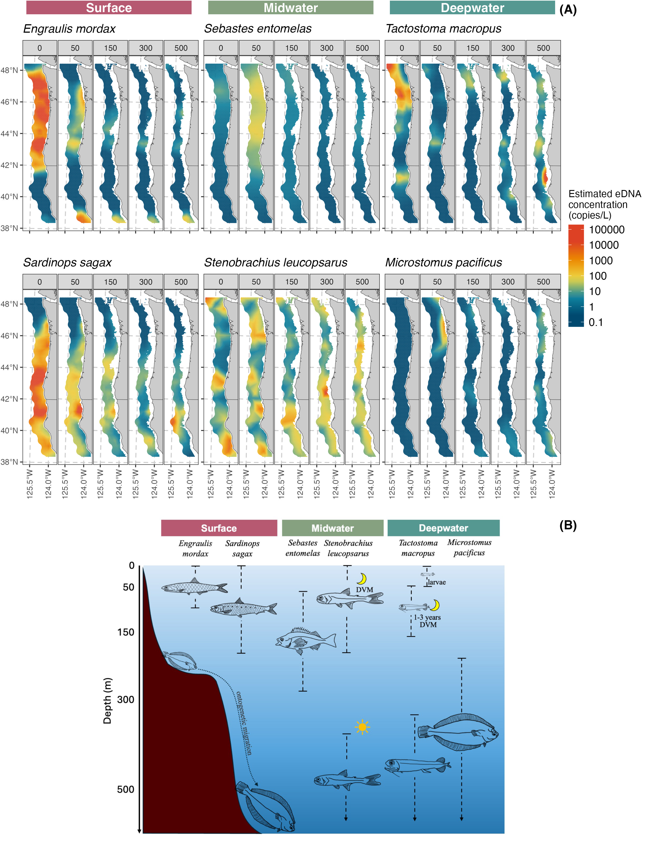

Estimated species (n=6; for the remaining species see [SI Appendix, Fig. S1](SI_Appendix.pdf)) eDNA concentration (A) across 0, 50, 150, 300, and 500m depth samples and known depth distribution of those species from literature (B).

## Surface species

Northern anchovy (*Engraulis mordax*) and Pacific sardine (*Sardinops sagax*) are the two iconic coastal pelagic species of the eastern North Pacfic (Steinbeck 1945) and play a vital ecological role linking lower and upper trophic levels (e.g., Chinook salmon diets, sea lions, (Kaplan et al. 2019)); historically these supported large commercial fisheries particularly in California. While larvae and juveniles typically occupy the upper 50m, adults move to 100m during the day to avoid predators. Our eDNA estimates consistently reflect the expected three-dimensional distributions of known surface dwelling species, with high concentrations in surface waters for both species(Litz et al. 2008; Parnel, Emmett, and Brodeur 2008), and an accumulation pocket near the Columbia River outflow (46.2 $​^{∘}$ N; Fig. 2). Sardine favors slightly warmer temperatures and more southerly waters than anchovy (SST range from literature: 13–24 $​^{∘}$ C for sardine vs. 10–14 $​^{∘}$ C for anchovy). eDNA patterns tracked these differences with sardine eDNA in greatest abundance at 41 $​^{∘}$ N (range 40 $​^{∘}$–45 $​^{∘}$), while anchovy eDNA abundance was greatest at 43.5 $​^{∘}$ N (range 42 $​^{∘}$–48 $​^{∘}$; Fig. 5) such that eDNA captured subtle yet meaningful differences in habitat preferences. When comparing the magnitude difference between the two species, eDNA abundance patterns suggest a 2.5-fold higher abundance for anchovy than sardine which agree in direction with stock assessments for anchovy and sardine (an approximately 35-fold difference; (Kuriyama et al. 2022; Kuriyama, Zwolinski, and Hill 2022)). However, due to differences in stock definitions and survey areas (the anchovy stock assessment includes southern California waters (32.5 $​^{∘}$–36 $​^{∘}$ N) not covered by the eDNA survey) these magnitudes are not directly comparable.

## Midwater species

Widow rockfish (*Sebastes entomelas*) is common between 100-350m between northern Baja California and southern Alaska, with pelagic larvae and juveniles generally detected in shallower habitats ( $<$ 150m depth) (Reynolds 2001; Bosley et al. 2014) including in nearshore kelp forests (Quigley et al. 2024; Laidig, Chess, and Howard 2007) . Moreover, because it is a common bycatch species in the Pacific hake (*Merluccius productus*) fishery, concerns about bycatch of widow rockfish can also influence the much larger hake fishery (i.e., it is a “choke” species for hake; (Somers et al. 2018)). Despite its commercial importance, no targeted survey effort exists for widow rockfish, in part because bottom trawls do not sample its pelagic habitat well. We find widow rockfish eDNA strongly and nearly exclusively associated with 50m sample depths (Fig. 2 and 5), consistent with the pelagic larvae and juveniles reported in the literature and somewhat shallower than adults (Reynolds 2001; Bosley et al. 2014; Quigley et al. 2024), potentially reflecting the species’ nocturnal feeding schooling behavior (Reynolds 2001; Bosley et al. 2014).

The eDNA patterns for northern lampfish (*Stenobrachius leucopsarus*) – an abundant myctophid that migrates from 400-700m up to 20-200m at night (Moku et al. 2000; Suntsov and Brodeur 2008) – are again consistent with the ecology of the species, having notably lower concentrations in surface samples. Owing to the diel vertical migration of the northern lampfish, the signal of eDNA for this species is observed across depths.

## Deepwater species

Among deeper-water fishes, eDNA revealed spatial and potentially ontogenetic migration patterns for species that are common, yet under studied, such as the dragonfish (*Tactostoma macropus*). Available literature suggests dragonfish occur roughly between 40 $​^{∘}$ N-50 $​^{∘}$ N (adults at 300-900m, larvae at 0-60m in summer) (Kawaguchi and Moser 1993) and perform diel vertical migrations to around 100 meters (Kawaguchi and Moser 1993; Willis and Pearcy 1982). The eDNA concentrations appeared to reflect this activity (Fig. 5), with the predominant surface signal at northern latitudes likely reflecting larvae and juveniles (Fig. 2; near Columbia River discharge), and two deeper hotspots at 300m and 500m separated by about eight degrees of latitude. However, no other quantitative estimates of abundance or detailed distribution patterns for dragonfish exist in the current literature.

Also consistent with known habitats are commercially caught flatfish such as Dover sole (*Microstomus pacificus*), which lives at 200m to 1200m along the Pacific coast (C. J. Drazen 2007; Brodziak and Mikus 2000; J. C. Drazen and Haedrich 2012); individuals move progressively deeper as they grow (Vetter et al. 1994; Hunter et al. 1990). The eDNA concentration estimates are consistent with this pattern, showing high concentrations mostly in water samples collected close to the seabed (Fig. 2) (Ono et al. 2016).

## Species Associations

Pairwise correlations of DNA concentration showed meaningful patterns among species associated with depth (Fig. 3). Surface-associated species were nearly all positively correlated with each other, with some correlations particularly large (Pearson’s $ρ>0.50$; Fig. 3). Correlations were weak among the six midwater and deepwater species (all $ρ<\left|0.40\right|$; Fig. 3). Within the surface species, further subdivision was also apparent, with chub mackerel (*Scomber japonicus*) and sardine (*Sardinops sagax*) showing very high correlation ($ρ=0.76$; Fig. 3) with both more common in the more southern (and somewhat warmer) waters (Fig. 2 and Fig. 5). Concentrations of the remaining surface-dwelling species (Northern anchovy, eulachon, jack mackerel, and Pacific herring) had modest correlations with midwater species (Fig. 3) consistent with more northerly distribution (Fig. 5). Together these findings suggest that eDNA is capturing both depth and latitudinal habitat associations. Deep-water species are distinct (Fig. 2 and Fig. 5) and not strongly correlated with those from other zones (Fig. 3). Deeper water tends to feature lower and more diffuse fish eDNA concentrations (Fig. 2 and Fig. 5). Lower overall eDNA concentrations and fewer deep water samples may make similarities among species distributions more difficult to detect at 300m and deeper.

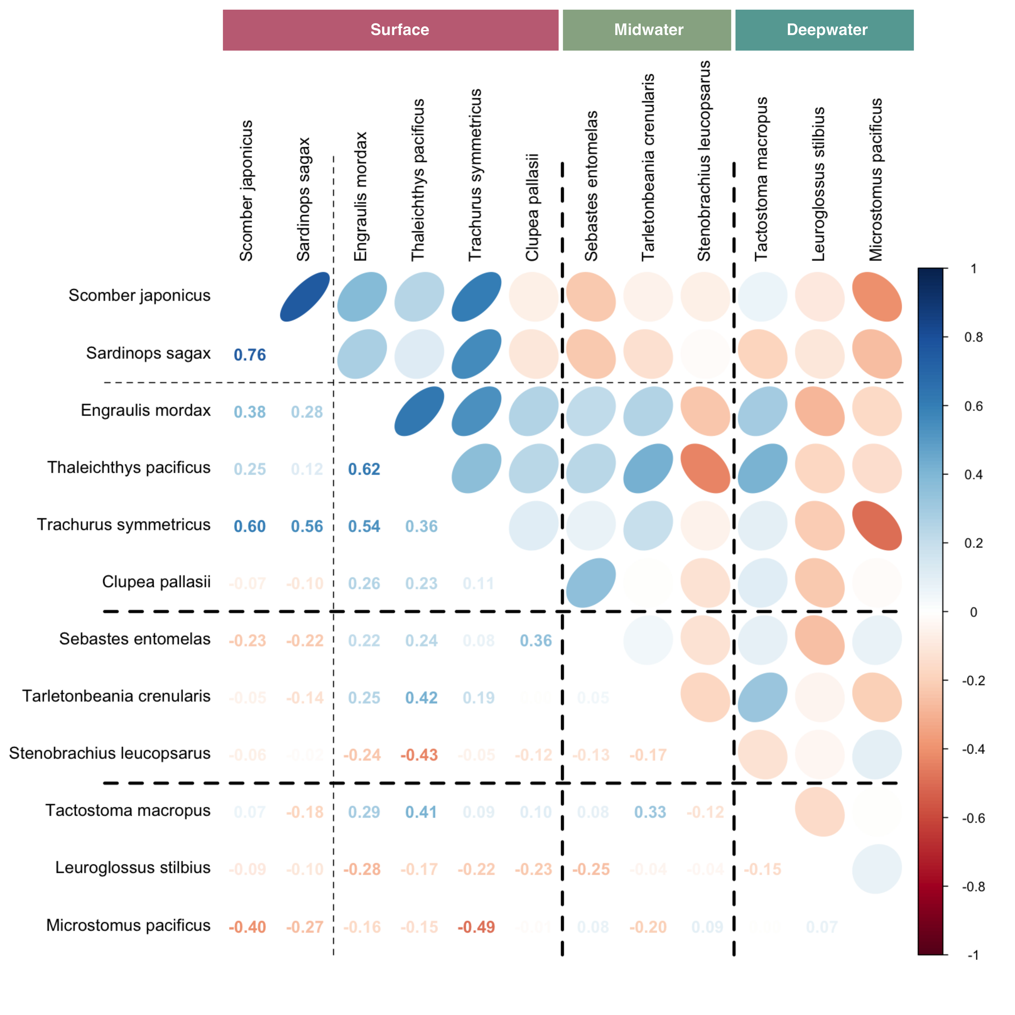

Correlation plot describing species co-abundance and co-occurance. Spearman’s $ρ$ correlation coefficient are expressed in numbers and colors ranging from -1 (red) negatively correlated to 1 (blue) positively correlated. Species are ordered in known ecological groups (surface, midwater, and deepwater) to visually indicate the gradual change of species co-occurance.

## Species richness and total eDNA accumulation

In addition to providing species-specific patterns, eDNA metrics of abundance from individual species can be combined to reveal important aggregate ecological patterns. For the 12 species considered here, we show how species richness (see [SI Appendix, Fig. S2](SI_Appendix.pdf) for defining species presence) from eDNA varied substantially and predictably with depth, with the highest richness observed at the surface (Fig. 4*A*). In part, this pattern is likely to be an artifact of the focal species included in this study – chosen for their relevance to fisheries management as well as for their frequency in the observations (see Methods) – but the richness-depth gradient also reflects the expectation that habitat and nutrient availability is greatest near the surface (Smith and Brown 2002; B. Hickey et al. 2005). Surface waters also host the eggs, larvae, and juvenile stages of many meso- and bathypelagic species (Parnel, Emmett, and Brodeur 2008), some of which we have included here, and hence we both expect and observe higher richness in the upper layer of the water column (Kim and Barth 2011).

Species richness also corresponds strongly with the influence of Columbia River plume (Fig. 4*A*), which extends well beyond the coastline (Barbara M. Hickey and Banas 2003). The nitrate-rich river water interacts with ocean currents and intensifies coastal upwelling, enhancing both primary and secondary productivity (B. M. Hickey et al. 2010) and likely influencing the patterns of species richness we observe (Fig. 4*A*) (Tolimieri et al. 2015). The total fish eDNA accumulation (Fig. 4*B*) suggests the highest aggregation of forage fish DNA near Heceta Bank (44 degrees N; overlapping anchovy and sardine distributions are the two largest contributors to the observed peak of accumulated eDNA concentration) in addition to other commercialy important mesopelagic fish (*Sebastes entomelas* and *Tarletonbeania crenularis*) a center of abundance for commercial fisheries (Bosley et al. 2014; Tissot et al. 2008), and elsewhere nearshore in areas of coastal upwelling.

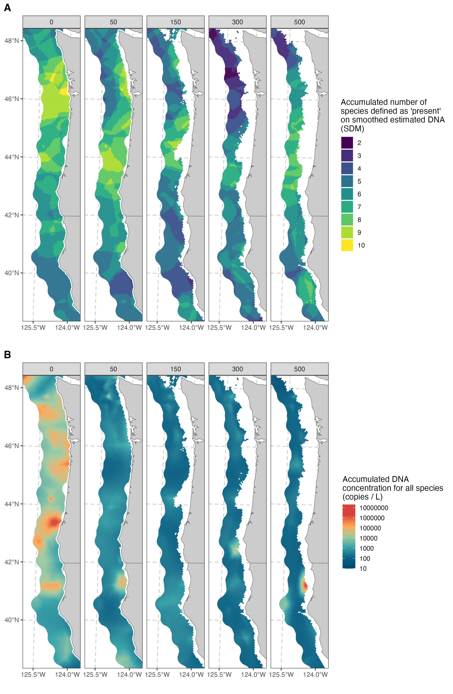

Spatial and vertical distribution of species richness (A) and environmental DNA (B) concentration across depths (0, 50, 150, 300, and 500 m). (B) Species richness represented as the cumulative number of species present (species with higher than 1.5 copies/L (see Fig. 5 for defining presence) on smoothed estimated eDNA concentrations) and acumulated eDNA concentration representing the cumulative sum of eDNA (copies/L) across all species.

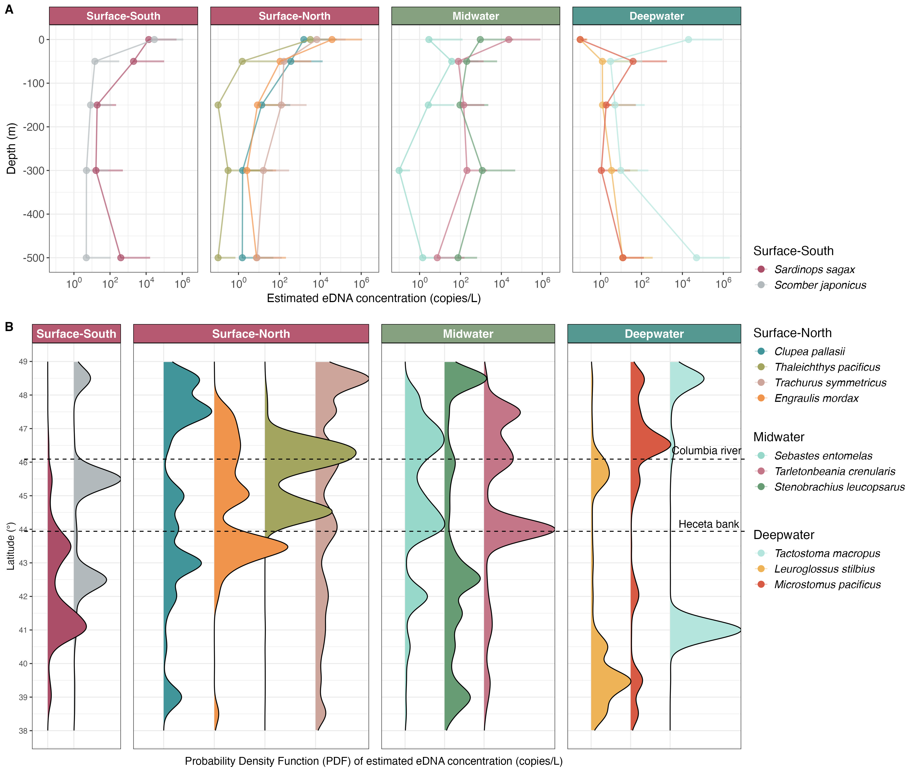

Vertical (A) and latitudinal (B) distribution of eDNA concentrations grouped in ecological groups (surface south, surface north, midwater, and deepwater). Mean eDNA concentration of vertical distribution is shown with dots and 99% upper quantile with ticks (A). Probability density functions (PDF) of estimated eDNA concentrations across latitudinal gradients (B; square root transformed of x-axis to enhance low concentration peaks). Key geographic features, such as the Columbia River and Heceta Bank, are marked to indicate alignment of species distributions.

# Discussion

We report species-specific DNA concentrations smoothed over ten degrees of latitude and across the continental shelf to 500m. We reveal distributional patterns for 12 species ranging from the iconic coastal pelagic species of the northeast Pacific to understudied-but-abundant deepwater species, and our results suggest clear pathways for the broader use of eDNA in both fisheries and ecosystem management.

## eDNA as Management Tool

By mapping three-dimensional spatial patterns, eDNA provides information on species distributions, habitat preferences, and ecological processes that is often otherwise unavailable. A single water sample can yield quantitative information on tens to hundreds of species – including for species for which traditional fisheries surveys are not currently conducted – without the need to develop species-specific assays. We find species-level eDNA concentrations align closely with the preferred habitats’ physiological constraints (e.g., temperature tolerance or food availability) described for each species in the available literature. The observed latitudinal differences of eDNA concentration among species – such as those between anchovy and sardine – highlights species’ thermal ranges and largely coincide with other surveys (Zwolinski and Demer 2024); moreover, eDNA patterns appear to reflect diel vertical migrations as observed in myctophids, where eDNA concentrations are consistent with the species’ ontogenetic movement between surface and mid- to deep-water habitats. We also identify aggregations of richness and total eDNA near high-productivity regions of ecological and commercial value.

For well-studied taxa, existing information helps contextualize eDNA signals, providing insights into habitat preferences, seasonal patterns, or temperature tolerances. For poorly studied species, eDNA serves as an exploratory tool, detecting elusive taxa and revealing unexpected habitats. Widow rockfish, for example, appear almost exclusively in pelagic habitats around 50m deep, which are sampled poorly by traditional bottom-trawl surveys (Keller, Wallace, and Methot 2017). This species has been of special interest, as its targeted commercial harvest resumed in the late 2010s after a decade of closure (harvest was less than 500 mt annually between 2003 and 2013 but has exceeded 10,000 mt annually since 2018) and no existing survey adequately captures its patterns of abundance (Adams et al. 2019).

## Environmental Smoothing

Our findings illustrate the power of eDNA as a transformative tool for fisheries management, biodiversity conservation, and the study of environmental change. However, the observable eDNA signal at any given location and time is an integrated product of DNA production and loss across time and space (Gold et al. 2023): the vast majority of DNA detectable in a given sample is of recent origin (within the previous hours to days (Strickler, Fremier, and Goldberg 2015; Collins et al. 2018; Mächler, Osathanunkul, and Altermatt 2018)), and it may be subject to a degree of physical transport within its window of detectability. Accordingly, the vast majority of DNA will be relatively proximate to its source in both space and time, and the distribution of DNA from a given species at any given time will be smoother and more extensive when compared to the distribution of discrete source individuals. We refer to this as environmental smoothing of eDNA signal relative to the source organisms themselves.

The majority of eDNA shed into the environment dissipates from surface waters within hours (Andruszkiewicz Allan et al. 2021). Thus, the horizontal scale of environmental smoothing in our dataset likely spans several kilometers at most (Baetscher, Nuetzel, and Garza 2023). Given that our sampling area spans more than 1,200 km north to south and tens of km east to west, the spatial patterns we report are likely to reflect genuine differences in fish communities rather than artifacts of eDNA transport dynamics (Guri, Westgaard, et al. 2024). Vertical smoothing of eDNA signals appears minimal, with patterns at the scale of meters: shallow-water species (sardine, anchovy, herring) occur largely at the surface and 50m depth bins; Widow rockfish occurs almost exclusively at the 50m depth; species found throughout the water column are either diel vertical migrators or species occupying different depths at various life-history stages (Fig. 4*B*); and bottom-dwelling fishes are detected primarily at the deepest point sampled on any station.

Notably, the comparison between sample-specific eDNA estimation ([SI Appendix, Fig. S6](SI_Appendix.pdf)) and spatially smoothed maps (Fig. 2 and [SI Appendix, Fig. S1](SI_Appendix.pdf)) revealed minimal differences. Large-scale sampling combined with statistical smoothing mitigates many challenges associated with eDNA transport and degradation – which decouple the eDNA observations from their particular source organisms – allowing reliable detection of broad patterns in species distributions. Further methodological improvements may incorporate information about the ecology of eDNA itself, such as the degree to which observations of eDNA concentrations depend upon water temperature or other covariates (Jo et al. 2019).

## Integrating DNA with traditional surveys

Effective management of natural resources at large scales requires that we maximize the information content of existing sampling regimes. Here, we follow (Andrew Olaf Shelton et al. 2022), leveraging the same water samples to provide information on an additional 12 species of ecosystem and management importance. Elsewhere, a subset of these samples has yielded information on the distribution of marine mammals (Valdivia-Carrillo et al., n.d.). The repeated use of a single set of samples highlights an important strength of eDNA samples; they allow researchers to revisit and re-sequence the genetic material in archived samples as new research questions arise or attention shifts to different taxa. The use of these samples, from a targeted fisheries survey for hake, highlights the efficiency for which eDNA can effectively provide survey data for tens or hundreds of additional species for which traditional surveys do not exist.

This capacity for retrospective analysis allows historical samples to be re-examined at any point, insofar as the sample is not exhausted, thereby offering opportunities to address emerging priorities and to reconstruct past ecological conditions. For example, the ability to retrospectively pinpoint the origins and pathways of invasive species can inform targeted interventions, helping managers understand not only where an incursion began but also how it spread (Gilbey et al. 2021). Similarly, the capacity to trace the initial onset of harmful algal blooms or the earliest presence of pathogenic microbes enables researchers and policymakers to identify the underlying drivers of these events and mitigate future outbreaks (Shaw et al. 2019).

Moreover, integrating retrospective eDNA analyses a changing climate can enrich predictive frameworks by providing historically grounded baselines of community composition, thereby enhancing our understanding of ecosystem responses to environmental shifts. For example, (Dı́az et al. 2020) demonstrated how archived samples could be leveraged to reconstruct past fish communities using eDNA, thereby complementing traditional monitoring methods and further extend the utility of archived material. Such retrospective applications deepen and extend the value of every research expedition, ensuring that once-collected samples continue to yield valuable ecological insights over time. We therefore see eDNA as an important datastream that maximizes the information value of existing research cruises, rather than a means of replacing those cruises themselves.

We have shown an example of the potential value of multi-species eDNA analysis for fisheries and other natural-resource management questions (Ledger et al. 2024; Stoeckle et al. 2024), however, molecular patterns alone are unlikely to drive quantitative natural-resources decisions, in part because eDNA generally does not provide auxiliary information important for managing populations (e.g., information on size- or age structure, fecundity, sex, or disease). Relating observed eDNA concentrations to species mass requires data external to the eDNA signal (Guri, Shelton, et al. 2024); and in particular, requires that we understand proportionalities between eDNA concentration and biomass that may vary among species. We therefore see eDNA analysis as strengthening and extending existing surveys, with different data streams complementing one another.

Conventional fish surveys, such as trawling or mark-recapture methods, typically rely on a closure assumption - assuming static fish population during the sampling period (Bailey, MacKenzie, and Nichols 2014), which ignores the reality of fish movement within the study area thus introducing potential bias into abundance estimates (Rota et al. 2009). By contrast, eDNA analysis leverages the continuous shedding of DNA by fish, which decays over time with higher concentrations remaining fresh while older DNA persists at lower levels (Thomsen and Willerslev 2015; Jerde et al. 2011). This cumulative, time-integrated signal allows eDNA surveys to circumvent the closure assumption and provide a more accurate representation of fish presence and activity.

Adams, Grant D, Maia Kapur, Kristin McQuaw, Stephanie Thurner, Owen Hamel, Andi Stephens, and Chantel Wetzel. 2019. “Stock Assessment Update: Status of Widow Rockfish (*Sebastes Entomelas*) Along the U.S. West Coast in 2019.” {{Stock Assessment Update}}. Pacific Fishery Management Council, Portland, Oregon.

Allan, Elizabeth Andruszkiewicz, Ryan P. Kelly, Erin R. D’Agnese, Maya N. Garber‐Yonts, Megan R. Shaffer, Zachary J. Gold, and Andrew O. Shelton. 2023. “Quantifying Impacts of an Environmental Intervention Using Environmental DNA.” *Ecological Applications* 33 (8): e2914. <https://doi.org/10.1002/eap.2914>.

Anderson, Sean C., Eric J. Ward, Philina A. English, Lewis A. K. Barnett, and James T. Thorson. 2022. “sdmTMB: An R Package for Fast, Flexible, and User-Friendly Generalized Linear Mixed Effects Models with Spatial and Spatiotemporal Random Fields.” *bioRxiv*. <https://doi.org/10.1101/2022.03.24.485545>.

Andres, Kara J., David M. Lodge, and Jose Andrés. 2023. “Environmental DNA Reveals the Genetic Diversity and Population Structure of an Invasive Species in the Laurentian Great Lakes.” *Proceedings of the National Academy of Sciences* 120 (37): e2307345120. <https://doi.org/10.1073/pnas.2307345120>.

Andruszkiewicz Allan, Elizabeth, Weifeng Gordon Zhang, Andone C. Lavery, and Annette F. Govindarajan. 2021. “Environmental DNA Shedding and Decay Rates from Diverse Animal Forms and Thermal Regimes.” *Environmental DNA* 3 (2): 492–514. <https://doi.org/10.1002/edn3.141>.

Baetscher, Diana S., Hayley M. Nuetzel, and John Carlos Garza. 2023. “Highly Accurate Species Identification of Eastern Pacific Rockfishes (Sebastes Spp.) with High-Throughput DNA Sequencing.” *Conservation Genetics* 24 (5): 563–74. <https://doi.org/10.1007/s10592-023-01521-6>.

Bailey, Larissa L., Darryl I. MacKenzie, and James D. Nichols. 2014. “Advances and Applications of Occupancy Models.” *Methods in Ecology and Evolution* 5 (12): 1269–79. <https://doi.org/10.1111/2041-210X.12100>.

Blois, Steve de. 2020. “The 2019 Joint U.S.-Canada Integrated Ecosystem and Pacific Hake Acoustic-Trawl Survey: Cruise Report SH-19-06.” {{NMFS-NWFSC-PR-2020-03}}. U.S. Department of Commerce, NOAA Processed Report.

Bosley, Keith L., Todd W. Miller, Richard D. Brodeur, Katelyn M. Bosley, Ahna Van Gaest, and Anna Elz. 2014. “Feeding Ecology of Juvenile Rockfishes Off Oregon and Washington Based on Stomach Content and Stable Isotope Analyses.” *Marine Biology* 161 (10): 2381–93. <https://doi.org/10.1007/s00227-014-2513-8>.

Brodziak, Jon, and Robert Mikus. 2000. “Variation in Life History Parameters of Dover Sole, *Microstomus Pacificus*, Off the Coasts of Washington, Oregon, and Northern California.” *Fisheries Bulletin* 98 (4): 661–73. <https://api.semanticscholar.org/CorpusID:88240570>.

Callahan, Benjamin J., Paul J. McMurdie, Michael J. Rosen, Andrew W. Han, Amy Jo A. Johnson, and Susan P. Holmes. 2016. “DADA2: High-resolution Sample Inference from Illumina Amplicon Data.” *Nature Methods* 13 (7): 581–83. <https://doi.org/10.1038/nmeth.3869>.

Collins, Rupert A., Owen S. Wangensteen, Eoin J. O’Gorman, Stefano Mariani, David W. Sims, and Martin J. Genner. 2018. “Persistence of Environmental DNA in Marine Systems.” *Communications Biology* 1 (1): 185. <https://doi.org/10.1038/s42003-018-0192-6>.

DiBattista, Joseph D., Ashley M. Fowler, Indiana J. Riley, Sally Reader, Amanda Hay, Kerryn Parkinson, and Jean-Paul A. Hobbs. 2022. “The Use of Environmental DNA to Monitor Impacted Coastal Estuaries.” *Marine Pollution Bulletin* 181: 113860. <https://doi.org/10.1016/j.marpolbul.2022.113860>.

Dı́az, Cecilia, Franziska-Frederike Wege, Cuong Q. Tang, Alexandra Crampton-Platt, Heinz Rüdel, Elke Eilebrecht, and Jan Koschorreck. 2020. “Aquatic Suspended Particulate Matter as Source of eDNA for Fish Metabarcoding.” *Scientific Reports* 10 (1): 14352. <https://doi.org/10.1038/s41598-020-71238-w>.

Drazen, C. Jeffrey. 2007. “Depth Related Trends in Proximate Composition of Demersal Fishes in the Eastern North Pacific.” *Deep Sea Research Part I: Oceanographic Research Papers* 54 (2): 203–19. <https://doi.org/10.1016/j.dsr.2006.10.007>.

Drazen, Jeffrey C., and Richard L. Haedrich. 2012. “A Continuum of Life Histories in Deep-Sea Demersal Fishes.” *Deep Sea Research Part I: Oceanographic Research Papers* 61: 34–42. <https://doi.org/10.1016/j.dsr.2011.11.002>.

Gilbey, John, Gary Carvalho, Rita Castilho, Ilaria Coscia, Mark W. Coulson, Geir Dahle, Sofie Derycke, et al. 2021. “Life in a Drop: Sampling Environmental DNA for Marine Fishery Management and Ecosystem Monitoring.” *Marine Policy* 124: 104331. <https://doi.org/10.1016/j.marpol.2020.104331>.

Gloor, Gregory B., Jean M. Macklaim, Vera Pawlowsky-Glahn, and Juan J. Egozcue. 2017. “Microbiome Datasets Are Compositional: And This Is Not Optional.” *Frontiers in Microbiology* 8: 2224. <https://doi.org/10.3389/fmicb.2017.02224>.

Gold, Zachary J., Andrew O. Shelton, Helen R. Casendino, Joe Duprey, Ramón Gallego, Amy Van Cise, Mary Fisher, et al. 2023. “Signal and Noise in Metabarcoding Data.” *PLOS ONE* 18 (5): e0285674. <https://doi.org/10.1371/journal.pone.0285674>.

Guri, Gledis, Andrew Olaf Shelton, Ryan P Kelly, Nigel Yoccoz, Torild Johansen, Kim Præbel, Tanja Hanebrekke, Jessica Louise Ray, Johanna Fall, and Jon-Ivar Westgaard. 2024. “Predicting Trawl Catches Using Environmental DNA.” Edited by W Stewart Grant. *ICES Journal of Marine Science* 81 (8): 1536–48. <https://doi.org/10.1093/icesjms/fsae097>.

Guri, Gledis, Jon-Ivar Westgaard, Nigel Yoccoz, Owen S. Wangensteen, Kim Præbel, Jessica Louise Ray, Ryan P. Kelly, Andrew Olaf Shelton, Tanja Hanebrekke, and Torild Johansen. 2024. “Maximizing Sampling Efficiency to Detect Differences in Fish Community Composition Using Environmental DNA Metabarcoding in Subarctic Fjords.” *Environmental DNA* 6 (1): e409. <https://doi.org/10.1002/edn3.409>.

Hickey, B. M., R. M. Kudela, J. D. Nash, K. W. Bruland, W. T. Peterson, P. MacCready, E. J. Lessard, et al. 2010. “River Influences on Shelf Ecosystems: Introduction and Synthesis.” *Journal of Geophysical Research: Oceans* 115: C00B17. <https://doi.org/10.1029/2009JC005452>.

Hickey, Barbara M., and Neil S. Banas. 2003. “Oceanography of the U.S. Pacific Northwest Coastal Ocean and Estuaries with Application to Coastal Ecology.” *Estuaries* 26 (4): 1010–31. <https://doi.org/10.1007/BF02803360>.

Hickey, B., S. Geier, N. Kachel, and A. MacFadyen. 2005. “A Bi-Directional River Plume: The Columbia in Summer.” *Continental Shelf Research* 25 (14): 1631–56. <https://doi.org/10.1016/j.csr.2005.04.010>.

Hunter, John R., John L. Butler, Carol Kimbrell, and Eric Lynn. 1990. “Bathymetric Patterns in Size, Age, Sexual Maturity, Water Content, and Caloric Density of Dover Sole, Microstomus Pacificus.” *California Cooperative Oceanic Fisheries Investigations Reports* 31: 132–44.

Jerde, Christopher L., Andrew R. Mahon, W. Lindsay Chadderton, and David M. Lodge. 2011. “‘Sight-unseen’ Detection of Rare Aquatic Species Using Environmental DNA: eDNA Surveillance of Rare Aquatic Species.” *Conservation Letters* 4 (2): 150–57. <https://doi.org/10.1111/j.1755-263X.2010.00158.x>.

Jo, Toshiaki, Hiroaki Murakami, Satoshi Yamamoto, Reiji Masuda, and Toshifumi Minamoto. 2019. “Effect of Water Temperature and Fish Biomass on Environmental DNA Shedding, Degradation, and Size Distribution.” *Ecology and Evolution* 9 (3): 1135–46. <https://doi.org/10.1002/ece3.4802>.

Kaplan, Isaac C., Tessa B. Francis, André E. Punt, Laura E. Koehn, Enrique Curchitser, Felipe Hurtado-Ferro, Kelli F. Johnson, et al. 2019. “A Multi-Model Approach to Understanding the Role of Pacific Sardine in the California Current Food Web.” *Marine Ecology Progress Series* 617-618: 307–21. <https://doi.org/10.3354/meps12504>.

Kawaguchi, Kouichi, and H. Geoffrey Moser. 1993. “Development and Distribution of the Early Life History Stages of the Mesopelagic Fish *Tactostoma Macropus* (Stomiidae) in the Transitional Waters of the North Pacific.” *Japanese Journal of Ichthyology* 40 (2): 161–72. <https://doi.org/10.11369/jji1950.40.161>.

Keller, Aimee A., John R. Wallace, and Richard D. Methot. 2017. “The Northwest Fisheries Science Center’s West Coast Groundfish Bottom Trawl Survey: History, Design, and Description.” {{NMFS-NWFSC-136}}. U.S. Department of Commerce, NOAA Technical Memorandum.

Kelly, Ryan P., David M. Lodge, Kai N. Lee, Susanna Theroux, Adam J. Sepulveda, Christopher A. Scholin, Joseph M. Craine, et al. 2024. “Toward a National eDNA Strategy for the United States.” *Environmental DNA* 6 (1): e432. <https://doi.org/10.1002/edn3.432>.

Kelly, Ryan P., Andrew Olaf Shelton, and Ramón Gallego. 2019. “Understanding PCR Processes to Draw Meaningful Conclusions from Environmental DNA Studies.” *Scientific Reports* 9 (1): 12133. <https://doi.org/10.1038/s41598-019-48546-x>.

Kim, Sangil, and John A. Barth. 2011. “Connectivity and Larval Dispersal Along the Oregon Coast Estimated by Numerical Simulations.” *Journal of Geophysical Research* 116 (C6): C06002. <https://doi.org/10.1029/2010JC006741>.

Kuriyama, Peter T., Juan P. Zwolinski, and Kevin T. Hill. 2022. “Update Assessment of the Pacific sardine resource in 2022 for U.S. management in 2022-2023.” NMFS-SWFSC-662. U.S. Department of Commerce, NOAA Technical Memorandum.

Kuriyama, Peter T., Juan P. Zwolinski, Steve L. H. Teo, and Kevin T. Hill. 2022. “Assessment of the Northern Anchovy (*Engraulis Mordax*) Central Subpopulation in 2021 for U.S. Management.” NMFS-SWFSC-665. U.S. Department of Commerce, NOAA Technical Memorandum.

Laidig, Thomas E., James R. Chess, and Daniel F. Howard. 2007. “Relationship Between Abundance of Juvenile Rockfishes (Sebastes Spp.) and Environmental Variables Documented Off Northern California and Potential Mechanisms for the Covariation.” *Fisheries Bulletin* 105 (39-48): 39–48.

Ledger, Kimberly J., Mary Beth Rew Hicks, Thomas P. Hurst, Wes Larson, and Diana S. Baetscher. 2024. “Validation of Environmental DNA for Estimating Proportional and Absolute Biomass.” *Environmental DNA* 6 (5): e70030. <https://doi.org/10.1002/edn3.70030>.

Litz, Marisa N. C., Selina A. Heppell, Robert L. Emmett, and Richard D. Brodeur. 2008. “Ecology and Distribution of the Northern Subpopulation of Northern Anchovy (*Engraulis Mordax*) Off the U.S. West Coast.” *California Cooperative Oceanic Fisheries Investigations Reports* 49: 167–82.

Liu, Owen R., Eric J. Ward, Sean C. Anderson, Kelly S. Andrews, Lewis A. K. Barnett, Stephanie Brodie, Gemma Carroll, et al. 2023. “Species Redistribution Creates Unequal Outcomes for Multispecies Fisheries Under Projected Climate Change.” *Science Advances* 9 (33): eadg5468. <https://doi.org/10.1126/sciadv.adg5468>.

Mächler, Elvira, Maslin Osathanunkul, and Florian Altermatt. 2018. “Shedding Light on eDNA: Neither Natural Levels of UV Radiation nor the Presence of a Filter Feeder Affect eDNA-Based Detection of Aquatic Organisms.” Edited by Hideyuki Doi. *PLOS ONE* 13 (4): e0195529. <https://doi.org/10.1371/journal.pone.0195529>.

Maes, Sarah M., Sam Desmet, Rein Brys, Klaas Sys, Tom Ruttink, Sara Maes, Kris Hostens, Lies Vansteenbrugge, and Sofie Derycke. 2024. “Detection and Quantification of Two Commercial Flatfishes *Solea Solea* and *Pleuronectes Platessa* in the North Sea Using Environmental DNA.” *Environmental DNA* 6 (1): e426. <https://doi.org/10.1002/edn3.426>.

Martin, Marcel. 2011. “Cutadapt Removes Adapter Sequences from High-Throughput Sequencing Reads.” *EMBnet.journal* 17 (1): 10. <https://doi.org/10.14806/ej.17.1.200>.

McLaren, Michael R., Amy D. Willis, and Benjamin J. Callahan. 2019. “Consistent and Correctable Bias in Metagenomic Sequencing Experiments.” *eLife* 8: e46923. <https://doi.org/10.7554/eLife.46923>.

Miya, M., Y. Sato, T. Fukunaga, T. Sado, J. Y. Poulsen, K. Sato, T. Minamoto, et al. 2015. “MiFish, a Set of Universal PCR Primers for Metabarcoding Environmental DNA from Fishes: Detection of More Than 230 Subtropical Marine Species.” *Royal Society Open Science* 2: 150088. <https://doi.org/10.1098/rsos.150088>.

Moku, Masatoshi, Kouichi Kawaguchi, Hikaru Watanabe, and Akinori Ohno. 2000. “Feeding Habits of Three Dominant Myctophid Fishes, *Diaphus Theta*, *Stenobrachius Leucopsarus* and *s. Nannochir*, in the Subarctic and Transitional Waters of the Western North Pacific.” *Marine Ecology Progress Series* 207: 129–40. <https://doi.org/10.3354/meps207129>.

Muenzel, Dominic, Alessia Bani, Maarten De Brauwer, Eleanor Stewart, Cilun Djakiman, Halwi, Ray Purnama, et al. 2024. “Combining Environmental DNA and Visual Surveys Can Inform Conservation Planning for Coral Reefs.” *Proceedings of the National Academy of Sciences* 121 (17): e2307214121. <https://doi.org/10.1073/pnas.2307214121>.

Ono, Kotaro, Andrew O. Shelton, Eric J. Ward, James T. Thorson, Blake E. Feist, and Ray Hilborn. 2016. “Space‐time Investigation of the Effects of Fishing on Fish Populations.” *Ecological Applications* 26 (2): 392–406. <https://doi.org/10.1890/14-1874>.

Parnel, Maria M., Robert L. Emmett, and Richard D. Brodeur. 2008. “Ichthyoplankton Community in the Columbia River Plume Off Oregon: Effects of Fluctuating Oceanographic Conditions.” *Fishery Bulletin* 106 (2): 161–73.

Pikitch, Ellen K., P. Dee Boersma, Ian L. Boyd, David O. Conover, Philippe M. Cury, Timothy E. Essington, Selina S. Heppell, et al. 2012. “Little Fish, Big Impact: Managing a Crucial Link in Ocean Food Webs.” In *Proceedings of the Lenfest Ocean Program*. <https://www.lenfestocean.org/~/media/legacy/Lenfest/PDFs/littlefishbigimpact_revised_12june12.pdf?la=en>.

Pont, Didier. 2024. “Predicting Downstream Transport Distance of Fish eDNA in Lotic Environments.” *Molecular Ecology Resources* 24 (4): e13934. <https://doi.org/10.1111/1755-0998.13934>.

Quigley, Lucinda A., Peter J. S. Franks, Andrew R. Thompson, John C. Field, and Jarrod A. Santora. 2024. “Quantifying the Fates and Retention of Larval Rockfish Through Lagrangian Analyses.” *Marine Ecology Progress Series* 749: 109–25. <https://doi.org/10.3354/meps14718>.

R Core Team. 2024. “R: A Language and Environment for Statistical Computing.” Vienna, Austria: R Foundation for Statistical Computing. <https://www.R-project.org/>.

Ramón-Laca, Ana, Abigail Wells, and Linda Park. 2021. “A Workflow for the Relative Quantification of Multiple Fish Species from Oceanic Water Samples Using Environmental DNA (eDNA) to Support Large-Scale Fishery Surveys.” *PLOS ONE* 16 (9): e0257773. <https://doi.org/10.1371/journal.pone.0257773>.

Reynolds, Julie Ann. 2001. “Habitat Associations and Distribution of Widow Rockfish, *Sebastes Entomelas*, with Implications for Marine Reserve Design.” PhD thesis, University of California, Berkeley. <https://www.proquest.com/dissertations-theses/habitat-associations-distribution-widow-rockfish/docview/304683138/se-2?accountid=14784>.

Rota, Christopher T., Robert J. Fletcher Jr, Robert M. Dorazio, and Matthew G. Betts. 2009. “Occupancy Estimation and the Closure Assumption.” *Journal of Applied Ecology* 46 (6): 1173–81. <https://doi.org/10.1111/j.1365-2664.2009.01734.x>.

Shaw, Jennifer L. A., Laura S. Weyrich, Gustaaf Hallegraeff, and Alan Cooper. 2019. “Retrospective eDNA Assessment of Potentially Harmful Algae in Historical Ship Ballast Tank and Marine Port Sediments.” *Molecular Ecology* 28 (10): 2476–85. <https://doi.org/10.1111/mec.15055>.

Shelton, Andrew O., Zachary J. Gold, Alexander J. Jensen, Erin D’Agnese, Elizabeth Andruszkiewicz Allan, Amy Van Cise, Ramón Gallego, et al. 2023. “Toward Quantitative Metabarcoding.” *Ecology* 104 (2): e3906. <https://doi.org/10.1002/ecy.3906>.

Shelton, Andrew O., Ryan P. Kelly, James L. O’Donnell, Linda Park, Piper Schwenke, Correigh Greene, Richard A. Henderson, and Eric M. Beamer. 2019. “Environmental DNA Provides Quantitative Estimates of a Threatened Salmon Species.” *Biological Conservation* 237: 383–91. <https://doi.org/10.1016/j.biocon.2019.07.003>.

Shelton, Andrew Olaf, Ana Ramón-Laca, Abigail Wells, Julia Clemons, Dezhang Chu, Blake E. Feist, Ryan P. Kelly, et al. 2022. “Environmental DNA Provides Quantitative Estimates of Pacific Hake Abundance and Distribution in the Open Ocean.” *Proceedings of the Royal Society B: Biological Sciences* 289 (1971): 20212613. <https://doi.org/10.1098/rspb.2021.2613>.

Smith, Katherine F., and James H. Brown. 2002. “Patterns of Diversity, Depth Range and Body Size Among Pelagic Fishes Along a Gradient of Depth.” *Global Ecology and Biogeography* 11 (4): 313–22. <https://doi.org/10.1046/j.1466-822X.2002.00286.x>.

Somers, Kayleigh A., Lisa Pfeiffer, Stacey Miller, and Wendy Morrison. 2018. “Using Incentives to Reduce Bycatch and Discarding: Results Under the West Coast Catch Share Program.” *Coastal Management* 46 (6): 621–37. <https://doi.org/10.1080/08920753.2018.1522492>.

Stan Development Team. 2023. “Stan Modeling Language Users Guide and Reference Manual.” <https://mc-stan.org/>.

Steinbeck, John. 1945. *Cannery Row*. Viking Press.

Stoeckle, Mark Y., Jesse H. Ausubel, and Michael Coogan. 2022. “12S Gene Metabarcoding with DNA Standard Quantifies Marine Bony Fish Environmental DNA , Identifies Threshold for Reproducible Detection, and Overcomes Distortion Due to Amplification of Non‐fish DNA.” *Environmental DNA* 6 (1): e376. <https://doi.org/10.1002/edn3.376>.

Stoeckle, Mark Y., Jesse H. Ausubel, Greg Hinks, and Stacy M. VanMorter. 2024. “A Potential Tool for Marine Biogeography: eDNA-dominant Fish Species Differ Among Coastal Habitats and by Season Concordant with Gear-Based Assessments.” *PLOS ONE* 19 (11): e0313170. <https://doi.org/10.1371/journal.pone.0313170>.

Strickler, Katherine M., Alexander K. Fremier, and Caren S. Goldberg. 2015. “Quantifying Effects of UV-B, Temperature, and pH on eDNA Degradation in Aquatic Microcosms.” *Biological Conservation* 183: 85–92. <https://doi.org/10.1016/j.biocon.2014.11.038>.

Suntsov, Andrey V., and Richard D. Brodeur. 2008. “Trophic Ecology of Three Dominant Myctophid Species in the Northern California Current Region.” *Marine Ecology Progress Series* 373: 81–96. <https://doi.org/10.3354/meps07678>.

Thomsen, Philip F., and Eske Willerslev. 2015. “Environmental DNA – An Emerging Tool in Conservation for Monitoring Past and Present Biodiversity.” *Biological Conservation* 183: 4–18. <https://doi.org/10.1016/j.biocon.2014.11.019>.

Tissot, Brian N., W. Waldo Wakefield, Mark A. Hixon, and J. Clemons. 2008. “Twenty Years of Fish-Habitat Studies on Heceta Bank, Oregon.” In *Marine Habitat Mapping Technology for Alaska*, edited by J. R. Reynolds and H. G. Greene. Alaska Sea Grant for North Pacific Research Board. <https://api.semanticscholar.org/CorpusID:44677461>.

Tolimieri, N., A. O. Shelton, B. E. Feist, and V. Simon. 2015. “Can We Increase Our Confidence about the Locations of Biodiversity ‘Hotspots’ by Using Multiple Diversity Indices?” *Ecosphere* 6 (12): 1–13. <https://doi.org/10.1890/ES14-00363.1>.

Valdivia-Carrillo, Tania, Megan Shaffer, Kim Parsons, Eiren K. Jacobson, Andrew O. Shelton, Ally Im, Krista M. Nichols, et al. n.d. “Leveraging Metabarcoding and Generalized Additive Models to Describe Cetacean eDNA Distribution Along the Washington State Coast Using Opportunistic Samples.”

Veilleux, Heather D., Melissa D. Misutka, and Chris N. Glover. 2021. “Environmental DNA and Environmental RNA: Current and Prospective Applications for Biological Monitoring.” *Science of The Total Environment* 782: 146891. <https://doi.org/10.1016/j.scitotenv.2021.146891>.

Vetter, Russell D., Eric A. Lynn, Morales-de la Garza, and A. S. V. Costa. 1994. “Depth Zonation and Metabolic Adaptation in Dover Sole, Microstomus Pacificus, and Other Deep-Living Flatfishes: Factors That Affect the Sole.” *Marine Biology* 120 (1): 145–59. <https://doi.org/10.1007/BF00381950>.

Willis, Jonathan M., and William G. Pearcy. 1982. “Vertical Distribution and Migration of Fishes of the Lower Mesopelagic Zone Off Oregon.” *Marine Biology* 70 (1): 87–98. <https://doi.org/10.1007/BF00397299>.

Zwolinski, Juan P., and David A. Demer. 2024. “An Updated Model of Potential Habitat for Northern Stock Pacific Sardine (*Sardinops Sagax*) and Its Use for Attributing Survey Observations and Fishery Landings.” *Fisheries Oceanography* 33 (3): e12664. <https://doi.org/10.1111/fog.12664>.